Sister to Sister International, Inc. (STSI)

# STEAM Academy (October 1st - May 3lst)

## PLEASE PRINT ALL INFORMATION

Application Date: _/_/

Name Age---- Date of Birth---*I*

--*I* -

Address Apt. City Zip Code _

E-mail address Phone (Home) _

Grade Name of School

Average grade this year in Math ----- Science ------

Guidance Counselor or Teacher Name Parent/Guardian Name Cell#

E-mail

**APPLICATIONS ARE REVIEWED ON A REVOLVING BASIS**

# A Completed Application Package Requires:

* A completed application form;
* A (1.5 to 2) page letter noting your academic and community accomplishments, thus far and why you think participating in our STEAM Academy will be beneficial to you (required for **new applicants**);
* A letter of recommendation on letterhead from a school, or civic member of the community who has worked with you for at least 6 months and can attest to your commitment/work ethic (required for **new applicants**);
* A copy of your most recent report card or transcript;
* An interview for all finalists will be required prior to admission.

## SELECTION PROCESS & CRITERIA

The selection process will include a review of all completed application packages by a STSI Review Committee from diverse academic and professional backgrounds. Applicants will be judged based on their interest in pursuing a career or being exposed to STEAM / Health Careers, academic success, proven ability to work with others, and desire to make contributions to our community and society-at-large. (Over - signature required)

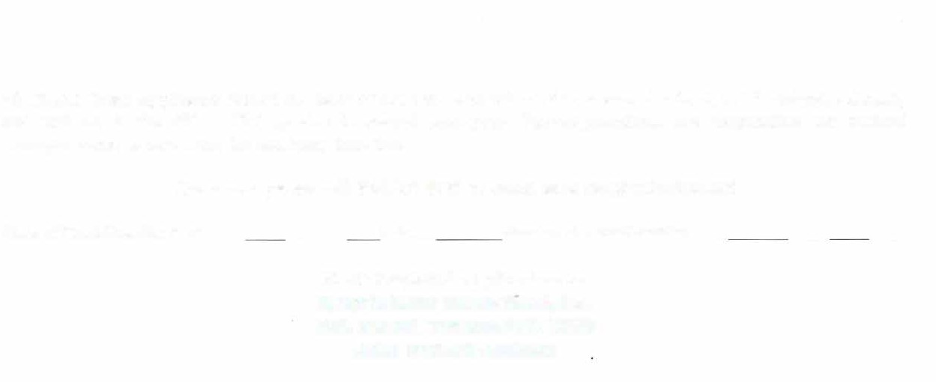

**\*STEAM Camp applicants should be Black or girls of color who reside or attend schools in Westchester County and will be in the 7th - 12th grades next school year. Parent/guardians are responsible for student transportation to and from the academy host site.**

**Questions, please call: 914.207.0368 or email us at** [**stsi@optonline.net**](mailto:stsi@optonline.net)

Name of Parent/Guardian Print Date:_ Signature of Parent/Guardian

**Mail Completed Applications to: Sister to Sister International, Inc.**

**P.O. Box 351 Yonkers, N.Y. 10703 Attn: STEAM Academy**